Requirement Analysis
Technology Stack (Architecture & Stack)
Date | 5 September 2026
Student Name | Bantupalli Niharika
Project Name | Automated Network Request Management
Maximum Marks

Technical Architecture
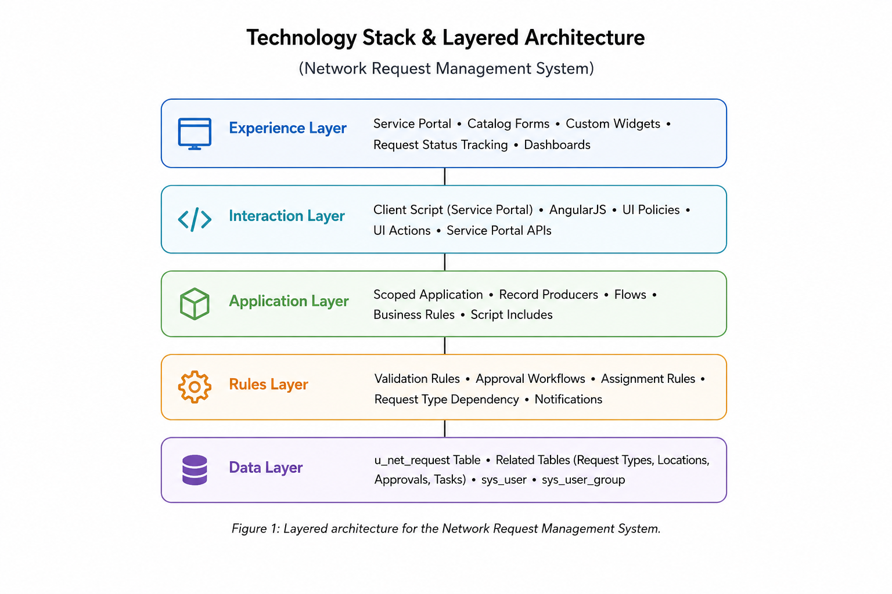

S.No. | Component | Description | Technology
1 | User Interface | Employee-facing portal for submitting network requests. | Service Portal / Employee Center
2 | Application Logic | Handles network request submission and processing. | ServiceNow Scoped Application / Service Catalog
3 | Rules | Validates fields and displays relevant options dynamically. | Catalog UI Policies / Client Scripts
4 | Data | Stores network request details and related records. | Network Request Table / REQ / RITM / sys_user
5 | Automation | Handles approvals and creates network fulfillment tasks. | Flow Designer / Approvals
6 | Fulfillment | Assigns and manages network-related tasks. | Catalog Tasks / Assignment Groups

